Name: Vasu Choudhary

Roll No: A251

SAP ID: 70012000337

B Tech IT 2nd Year

OOP Mini Project

**TIC TAC TOE GAME**

Program Demo

* First Extract the file A251 Vasu Choudhary Mini Project.zip
* Then open the Command Prompt.
* Then Change the Directory of command prompt where project file is saved like given below:

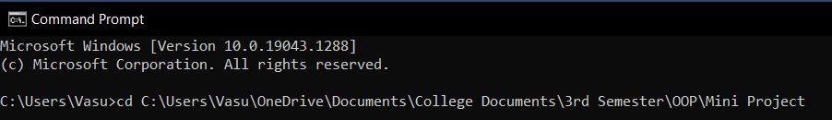

* Then Compile the file name “Login.java” and “MainPage.java” using cmd like given below:

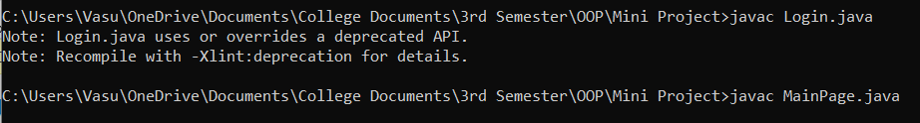

* Now Run the Program “Login” using cmd:



* A new Window will Open

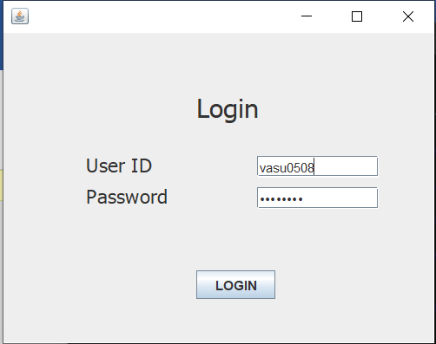

* User ID and Password is “vasu0508” and is setted as default value of program.
* If you will Enter wrong User ID or Password , Window shown below will appear.

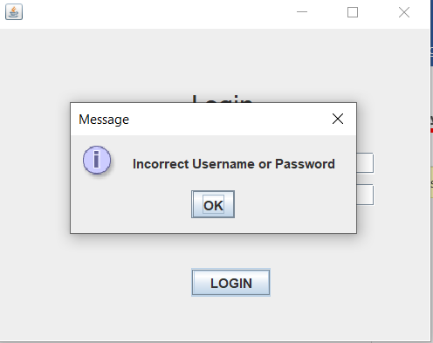

* If you will Enter Correct User ID and Password MainPage program will run that will open a new window which is our Main Program TIC TAC Toe Game.

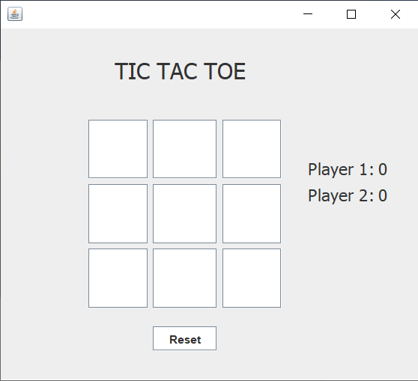

* It is a two player game where in which player 1 moves first with cross and player 2 mover second gets circle, and we have to make group of 3 adjacent crosses or circles to form a straight line in any direction to win the game.

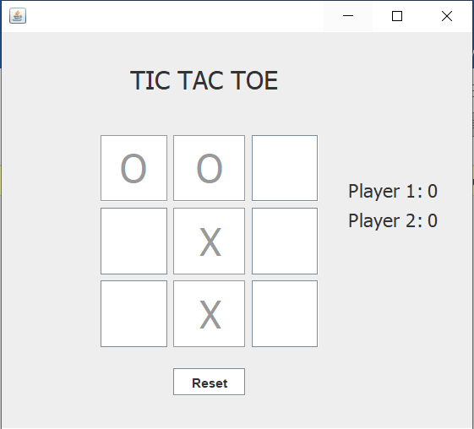

* If Player 1 wins it shows “Player 1 Won” and increments the Player 1 score by 1 and resets the game board for another game and vice versa with player 2.

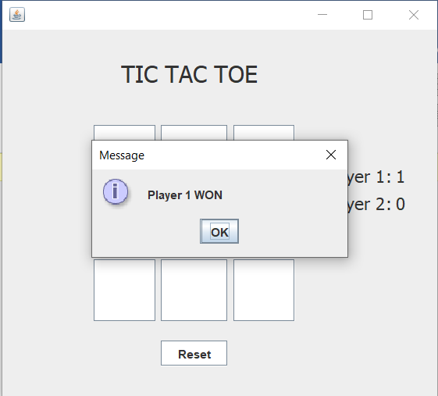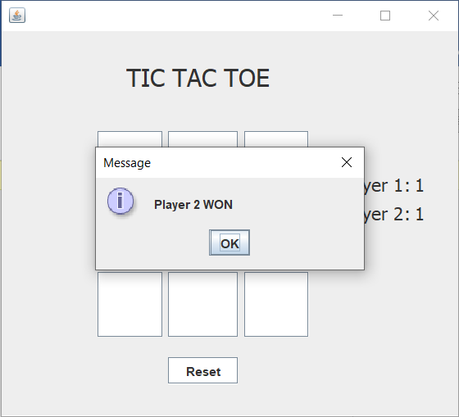

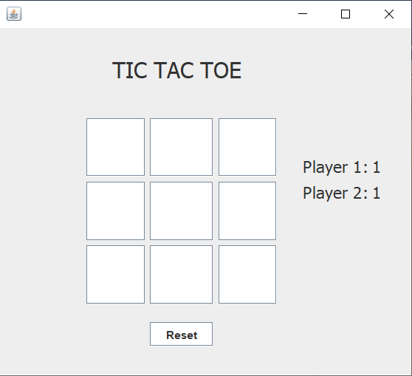

* If all the squares gets filled without any winner it shows a Message “Game Tied” and scores of both players remains the same and resets the board for next game.

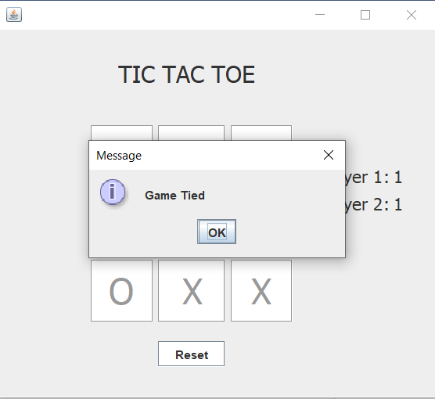

* If we press Reset Button Players scores will become 0 and it will reset the board.

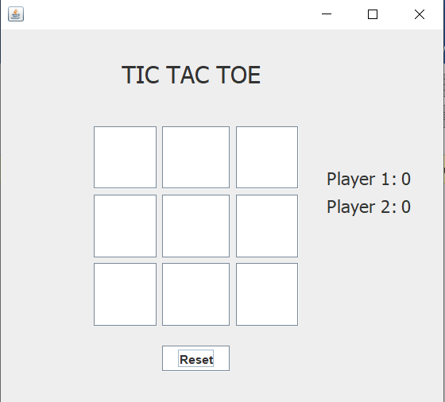

* So, This a game we can play and enjoy with our friends.

Note:-

If “Login.java” Program compilation shows error then we can also directly compile and run the program “MainPage.java”.

This Program was Made using Apache Netbeans IDE 12.4.

It was created using jFrame Form.

Code is present in the same zip file of the program.